
Community Friends Newsletter
3960 Winding Way Cincinnati, Ohio 45229
Fall 2023

INFORMATION CONCERNING OUR NEWSLETTER:
There will be three newsletters throughout the year following the seasons: Fall, Winter, and Spring/Summer. Publication will be on the 15th of September, the 15th of January, and the 15th of April.
Submission of:
Announcements, committee reports, reports from Quarterly and Yearly Meetings, creative expressions (literary, musical, and artistic), social activities, and social justice work and advocacy, educational activities, and various workshops are welcome.
Please send to campbellkaren430@gmail.com.
Do you have any other suggestions for submissions? Any subjects you would like explored?

First Sunday of the Month, weather allowing, is worship outside.
Religious Education for Children
Religious First Day Classes for children four and up will begin on September 10th.
Community Activities
Some suggestions for the Fall:
Apple Party to celebrate Johnny Appleseed’s Birthday ~ proposed for Saturday, September 23rd in the afternoon.
Campfire Stories and Songs ~ proposed for Saturday, October 10th, in the evening.
Winter Blessing Wreath (Craft) ~ proposed for Saturday, December 2nd in the afternoon.

Ministry and Council
Our planning for our Renewal continues for Oct. 28th which will be held at Quaker Knoll with the possibility of an overnight for those wanting to stay and worship there together Sunday morning. Diann Herzog from Fall Creek Meeting in Indiana will facilitate the program part: Community Stewardship of our Spiritual Ecosystem. There will be time for fellowship and wandering the grounds plus a catered dinner. Wilmington, OH - Quaker Knoll Campground.
Interesting resources:

https://youtu.be/RKWv8VJ77tk Addressing Environmental Issues as a Spiritual Community
About Us - QEW (quakerearthcare.org) Quaker Earth Care
Ministry and Council hopes to coordinate “Introduction to Quakerism” with other two Quaker Meetings.

Report of the Peace and Social Concerns Committee

Community Friends supports the following charities:

American Friends Service Committee, Home | American Friends Service Committee (afsc.org)
Quaker United Nations Office, QUNO | Quaker United Nations Office
Friends World Committee for Consultation, FWCC
Quaker Earthcare Witness, Home - QEW (quakerearthcare.org)

These charities supported by Community Friends Meeting are part of a larger coalition which has won the United Nations' highest human rights award. The coalition is the “Global Coalition of Civil Society, Indigenous Peoples, Social Movements, and Local Communities for the Universal Recognition of the Human Right to a Clean, Healthy, and Sustainable Environment.” This is the first time this award has been given to a global coalition of a thousand organizations. The UN Human Rights Award will be presented on December 10th, which marks the 75th anniversary of the Universal Declaration of Human Rights.

See following resources:

Quaker organizations celebrate UN human rights prize | American Friends Service Committee (afsc.org)

Quakers involvement in the UN Human Rights Prize 2023 | QUNO

Human Rights (quakersintheworld.org)

Report of the Adult Religious Education Committee

Fall Second Hour Ideas for the Fall, 2023:

Quaker Spiritual Elevator Pitches – personal and general – Don

“George Fox – Coming to the colonies.” This is the 400th birthday of George Fox and Friends worldwide are planning events to celebrate. So should we. See info below– Karen

Ministry and Counsel Committee want to facilitate an upcoming Second Hour on Quaker Process and Clerking (hopefully Nov. 19th).

Food Rescue. Supports our sustainability testimony.

The Sum of Us by Heather McGhee book discussion. Winner of The National Book Award. About American racism and the destructive nature of our divisive politics and cultural war. Tim may want to facilitate.

Other Committee ideas:

Quaker relations past and present with Native Americans – Karen.
- Allen McGrew is interested in sharing about the tragic events at White’s Institute Quaker Boarding School in Indiana. See, The Brutal History of Native Boarding Schools in Indiana | wthr.com.
- There are many good books that critique the nature of the Native American/ Quaker relationship. Perhaps we could have a book discussion with one of them. One possibility is A Lenape among the Quakers: The Life of Hannah Freeman by Dawn G. Marsh.
- Five years ago Pendle Hill hosted the “Truth and Healing Conference,” to seek the right relationship with indigenous peoples. There are five videos of presentations on YouTube. One example is: “Quaker Indian Boarding Schools,” presented by Paula Palmer, May 4, 2018, about an hour and ten minutes long, Paula Palmer - Quaker Indian Boarding Schools - Truth & Healing Conference at Pendle Hill - YouTube. More information about Paula Palmer at Paula Palmer (boulderfriendsmeeting.org).
- The Washington Newsletter (July/August 2023) of the FCNL has an informative article “Advocacy Corps Succeeds in Lobbying for Truth and Healing Commission.” For ten months the 2022-2023 Advocacy Corps lobbied for the establishment of a Truth and Healing Commission on Indian Boarding Schools. In May Senator Elizabeth Warren reintroduced the “Truth and Healing Commission on Indian Boarding School Policy in the United States Act” (S. 1723). The following link is an excellent summary of this act: https://youtu.be/S4f1uHK4SiY?si=arKzJOwWurkvyQx8.
- Native American Boarding School Healing Collation, The National Native American Boarding School Healing Coalition (NABS).
- NCNL advocates for Native American tribal sovereignty and treaty rights, Native Americans | Friends Committee On National Legislation (fcnl.org). NCNL is working with Swarthmore and Haverford archives to digitize boarding school records:
  - Native American group to digitize 20,000 archival pages linked to Quaker-run Indian boarding schools | AP News

Feminism and spirituality – Pam

Climate Change and Biodiversity – Sandy

Pendle Hill Pamphlet Reading Group – John Yungblut

How to Center (Meditation Techniques)

Defibrillator

Please let the committee know your interests. Share your knowledge of resources, books and videos. Thank you.
******
The Arts as an Expression of Faith ~  Share your Gifts with the Meeting and  in this Newsletter  Sketch of George Fox by Karen Campbell | 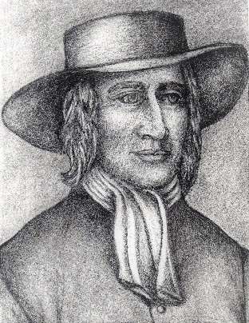

The “Word of God” is a creative Word uttered in Love. We are God’s creations who respond to the call to create too. In the Fall of 2022, the Adult Reglious Education Committee of our Meeting sent out a call for Friends to share their creativeness in preparation of the annual Christmas Talent Show. Our creativity born in the image of the Creator’s, our co-creativity in the Spirit, helps to reveal and spread the Light and its healing power. Accordingly, the discernment of our gifts, artistic and otherwise, is important and useful.
According to the “Fellowship of Quakers in the Arts” website (https://fqaquaker.org), the arts includes: Literary, Visual, Musical, and Performing Arts. Also included is a wide variety of crafts. The Meeting came up with a long list of gifts that people can share: Writing (Fiction and Non-Fiction), Playwriting and Screen Writing, Journal writing, Journalism, Poetry, Music/Chanting, Painting, Sculpture, Architecture, Design, Pottery/Ceramic, China Painting, Fiber Art, Textile Art, Embroidery, Quilt making, Printmaking, Woodwork, Photography, Theater Arts, Film, Gardening, Cooking, Crafts of all kinds. There are many more.
Examples from our 2nd hour Meeting: Franchot Ballinger who recently died published two poetry books, After the First Knowing and Crossings. Paulette Meier travels in the ministry to share her spiritual chants. Don Hutchinson shared his home make soaps and jams. Karen Campbell shared some portraits and drawings. Andrew Boniface also share his drawing. Jennifer Wolf shared her archive of illustrated wedding certificates. Mary Anne Curtiss shared her embroidery and Wilhelmina Branson shared crocheted lace. Gene Marquis on February 26th presented “Rock n’ Roll and Pop Music of an Anti-War Nature.”
We invite everyone to share their creativity with us in this newsletter. Send your examples to Karen Campbell, campbellkaren430@gmail.com.
Resources:
Quaker Arts Network (Great Britain), “Arts for Quaker spiritual nurture, witness and outreach (http://www.quakerarts.net).” Visit their Facebook page and read about their many art projects at http://www.facebook.com/quakerarts/.
Archive of the Fellowship of Quakers in the Arts; Types & Shadows : Fellowship of Quakers in the Arts.
List of articles on the arts in the Friends Journal: You searched for +arts - Friends Journal

Beyond Uneasy Tolerance: Compiled and chronologically arranged by Esther Greenleaf Mürer. Published June 2000 by the Fellowship of Quakers in the Arts, aided by the Publications Grants Group of Philadelphia Yearly Meeting, 64 p. Price: US $5.00. This pamphlet tells the dramatic and little-known story of the evolution of Quaker attitudes toward the arts from antipathy to acceptance. The story is presented in the form of brief quotations from Quaker writings on the arts, arranged chronologically from the 1650s to 1995.

Actually, George Fox, as well as other early Friends, disapproved of the arts and was iconoclastic. I’m sure he would disapprove of my sketch of him. He would find it “useless” and unspiritual.
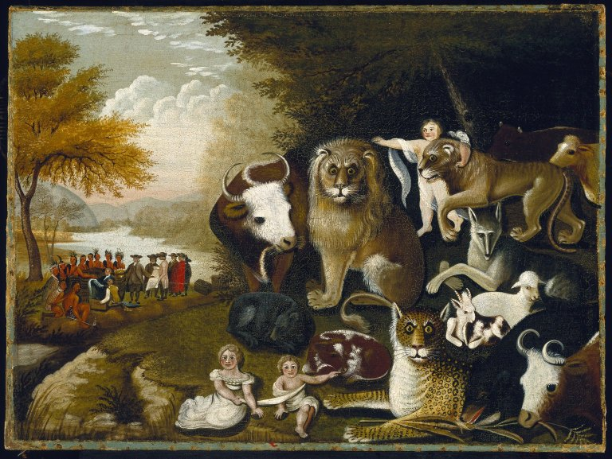 | On-the-other-hand, Edward Hicks, famous Hicksite minister, a little over 100 years later, was also a painter of primitive paintings, his most famous being “The Peaceable Kingdom.”

****
An Example of Artistic Inspiration Created in Community ~
The Kendal Quaker Tapestry, Cumbria, England.
Completed in 1996
Tapestry Museum ~ Home - Quaker Tapestry (quaker-tapestry.co.uk)
4,000 people over twelve years completed the Tapestry of 77 panels
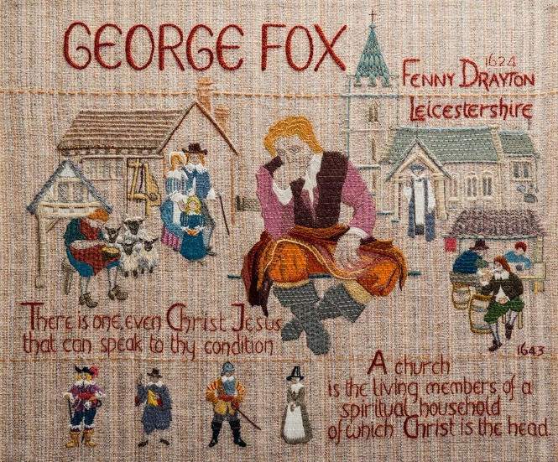
6th Annual Cincinnati Festival of Faith
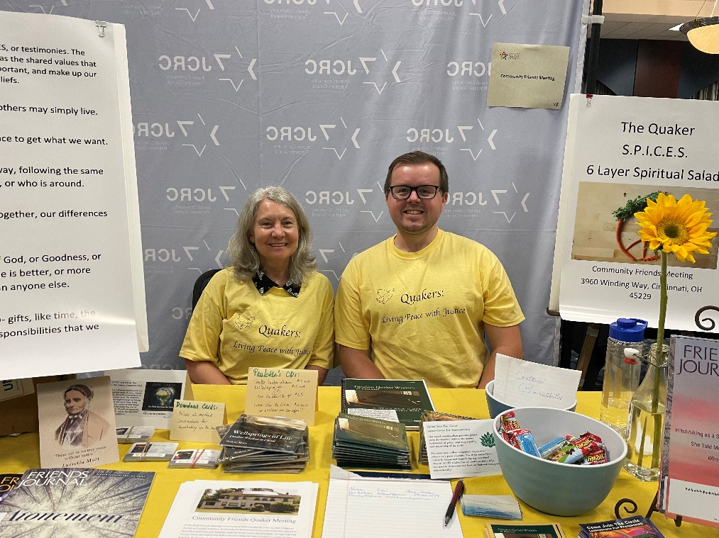
Our booth at the Festival of Faith, August 27th, 2023 ~ Celebrating the religious diversity of our area at Xavier’s Centas Center.
About the Festival - EquaSion
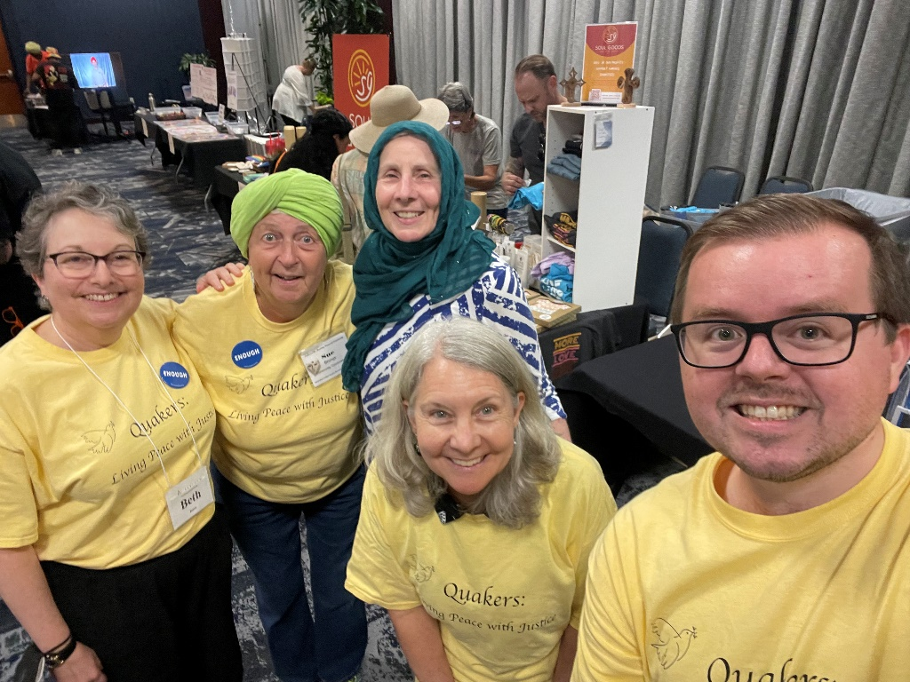

400th Birthday Celebration of George Fox


Friends World Committee for Consultation has announced that July 2024 will be the 400th celebration of George Fox’s birthday:
“Although Fox was born in July, celebrations will take place throughout the year, including an all-age party at the historic Arch Street Meeting House in Philadelphia, a special exhibition at the Quaker Tapestry museum, celebrations at Australia Yearly Meeting and New Zealand Summer gathering, a video project facilitated by the Quaker Arts Network, and two special editions of the journal Quaker Religious Thought” (George Fox’s 400th Birthday – FWCC).
A George Fox Birthday Pack full of activities for children and adults can be found at George-Fox-400-Birthday-Pack.pdf (fwcc.world).
Throughout this year facts and stories about George Fox will be included in this newsletter. Two suggestions for future 2nd hour topics from our Education Committee are: George Fox’s Journey to the Americas and Quaker Relations Past and Present to Native Americans. Any other suggestions are very much appreciated.
An Introduction to Fox’s Journey to the Americas (the Caribbean and southeast America): After attending the first Yearly Meeting in England, George Fox traveled to Barbados arriving in October of 1671. His traveling companions were twelve men and two women. They sailed on a swift but leaky ship finally arriving at Carlisle Bay. For the first three weeks Fox was ill. He recovered and stayed in Barbados for three months before leaving for Jamaica. The situation in Barbados for Friends mirrored their experience of persecution in England. Friends had first settled there in 1655 and were a minority. When Fox arrived, there were five meeting. Friends had not tried to advocate for the slaves nor appeared to be antislavery. Fox visited Friends and there was a general meeting of Friends in Bridgetown. Fox was settling and strengthening meetings and Friends. He met and dined with the Royal governor of Barbados, Lewis Morice.
The greatest fear of the government was the fear of slave insurrections since there were more slaves on the island than Europeans. Much of Fox’s letter the Governor of Barbados is one of assurance that Friend would not encourage a slave rebellion. He also wrote an “apology” for Quakerism emphasizing its Christian roots hoping to promote understanding and tolerance since Friend’s pacifism made their loyalty to the state questionable. Many have expressed disappointment that George Fox did not challenge the Royal government more about slavery. He did, however, encourage slave owners to emancipate their slaves after thirty years of service.
For more information see:
“1671: Quaker Founder George Fox in Barbados,” Just World News, with Helena Cobban, 5/31/2021.
George Fox in Barbados: With the Complete Text of the Letter to the Governor of Barbados by Simon Webb (Langley Press, Durham, 2016).
“George Fox, Quakers, Negros and Slavery on Barbados, 1671-1675” by
Edward A. Macine. Essay written at Yale University (TriCollege Libraries, Bryn Mawr, Haverford, Swarthmore).
******
Report on the Community Friends Threshing Session on the Spiritual Basis for Racial and Economic Justice May 28, 2023, Second Hour

After reading the minutes of this Threshing Session, the Quaker belief in Spiritual Unity kept rolling around in my mind. Friends believe we find Unity together even when diverse in our opinions because we all participate directly in the same inner Spirit which leads to Unity. Even if there remains some concerns or even a disagreement, a way can open in the Light to find a consensus. Traveling in the Spirit together is the spiritual labor of discernment leading to Unity. This process is used in both meetings for worship and business. In-other-word, Unity is not imposed from above through structures of authority but arises from our open hearts. Of course, this is a long process of listening, honest exchange, and respect. It is not obedience to defined doctrine or dogma but is an ongoing process which is grounded in our belief in the continuing revelation of the Spirit.
In our society today we are experiencing extreme political divisions and anger; anything but unity. We are wrestling with serious social issues and injustices. Some Friends are fearful that when we discuss these issues, we forget the spiritual call for seeking justice. Our concern for racial and economic justice is not merely secular but is deeply rooted in our faith. We have a faith that is healing and renewing personally and can be transformative on a societal level too. It is God’s Spirit, also called the Light, in which we directly participate that is restorative, loving, and just. This Unity with the Spirit automatically leads to action in the world. The Spirit has always been motivational and inspirational. Early Friends believed in the coming consummation of the world and their own participation in the transformation of creation. They were being called to straighten the road and lower the mountains for the coming of the Lord through their obedience to the ongoing inspiring creative Spirit of God.
There was also a discussion concerning the nature of that which unites us and what to call that mysterious reality. Some people are troubled by the use of Biblical or overtly Christian terminology. The belief in a higher reality or spirituality is universal in world religions. Humanists and people of faith are not enemies and can be part of the great unity.
The extremism of today divides and wounds our culture by devolving the issues down into tropes and brands of the competing groups. These tropes and brands are superficial and inflammatory and warp or even suppress any moral and ethical considerations. Everything is made profoundly superficial; the ultimate concern being one of attaining power and not functioning out of love of others; not functioning out of the Spirit/Light.
This longed for unity is not a mere political type of unity. Friends seek to create a spiritual harmony of unity. A comparison was made with Jazz. During that same week, International Jazz Day was celebrated. It emphasized the universal and diverse qualities of Jazz. Jazz unifies people from all over the world. And, of course, the goal of Jazz musicians is to create, in an improvisational way, a unity of musical voices. Jazz musicians must listen deeply to each other to “dialog” with each other. This can be said for all types of music. For example, in Classical music there is the art of contrapuntal composition where there are two to four independent melody lines which move throughout a piece interwoven together to create a great harmony. The melodic voices of the characters in grand opera are embrace to create a great harmony.
Since the time of Pythagoras the belief in the unity of the musica universalis, “the harmony of the spheres” has persisted. All of creation hums due to astrological mathematical relationships which are “tones.” The universe is a great symphony of unity. I’m sure other examples of this concept of a higher unity can be found in other fine arts and liberal arts.
I asked myself, what is the spiritual grounding for “racial and economic justice” in the Judeo-Christian-Islamic tradition? I look to the Beatitudes for a grounding. Another spiritual essential is found in St. Paul’s praise of Love.
“If I speak in the tongues of mortals and of angels, but do not have love, I am a noisy gong or a clanging cymbal. And if I have prophetic powers, and understand all mysteries and all knowledge, and if I have all faith, so as to remove mountains, but do not have love, I am nothing. If I give away all my possessions, and if I hand over my body so that I may boast, but do not have love, I gain nothing.” (I Corinthians 13)
All great revolutionaries, who know how to “make good trouble,” have always known that everything is Love. It is this “agape” Love that bridges the divides (cultural or otherwise) and nurtures unity. And, Love is not hypothetical; it is concrete expressed in our treatment of others personally and on a societal level.
But there is always great hope in our faith. Like George Fox said:
“I saw, also, that there was an ocean of darkness and death; but an infinite ocean of light and love, which flowed over the ocean of darkness. In that also I saw the infinite love of God, and I had great openings.”
This “Threshing Session” is only the beginning of a continual sharing about our faith and our response to social injustice and needs. Like George Fox we believe that faith, hope, and love (the greatest of these is Love) will bless us with great openings.

Report on Discussion during 2nd Hour on subject of
Meeting for Business (MfB)
The following comments and suggestions were made:
Taking more breaks. It is a long time to sit.
Need more clarity about difference between unity and consensus.
Appreciation for Quaker belief that a “way will open.” The community needs to trust that a “way will open” even when each member is asked to speak only once.
Attending MfB is part of the responsibilities of members.
Primary reason people do not attend Meeting for Business (MfB) is that it is they must sit too long
It was noted that members are more likely to attend MfB if there is an action item to consider.
It was expressed how certain more traditionally Christian language about “spirit” can feel silencing to some members.
There was a suggestion raised to put recording clerk’s notes on the large screen to allow for visual processing.
Also it was suggested to try a different day and time for MfB (not after Worship). MfB after Meeting for Worship makes for a long day.

